Assignment 6

Task Description 1

• Use AI to complete a Student class with attributes and a method.
• Check output
• Analyze the code generated by AI tool

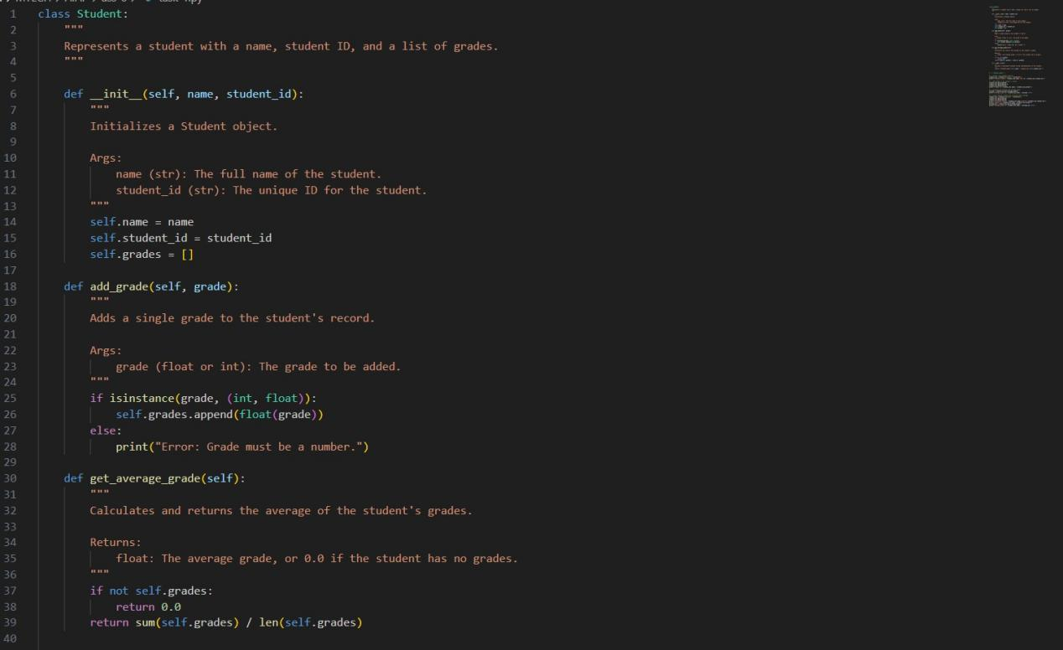

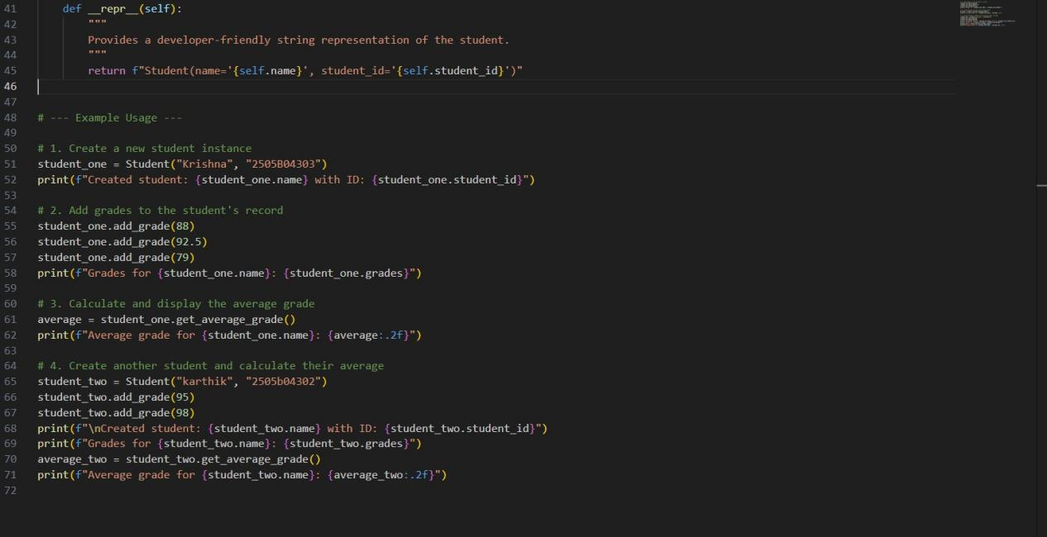

Practical Output:

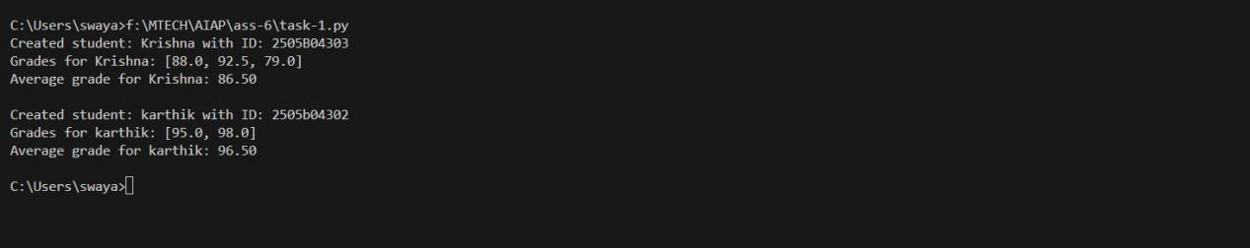

Task Description 2

• Prompt AI to complete a function that prints the first 10 multiples of a number using a loop.
• Analyze the generated code
• Ask AI to generate code using other controlled looping

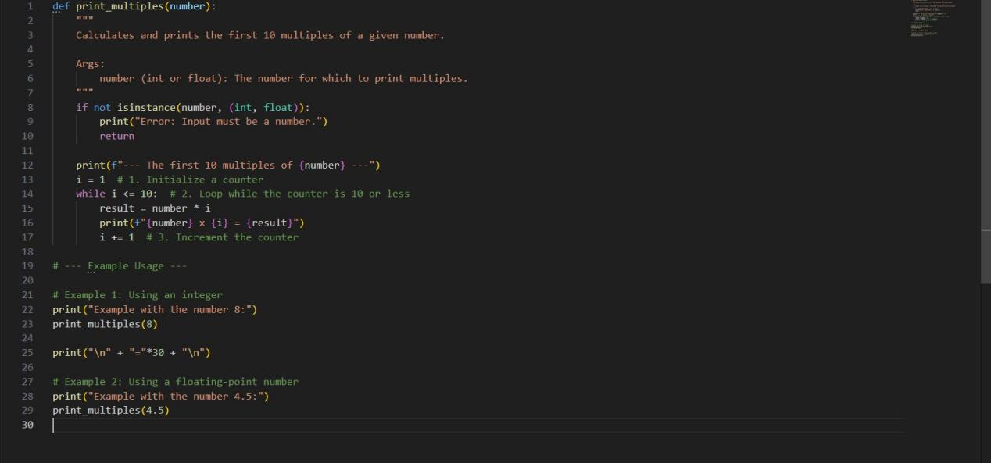

Practical Output:

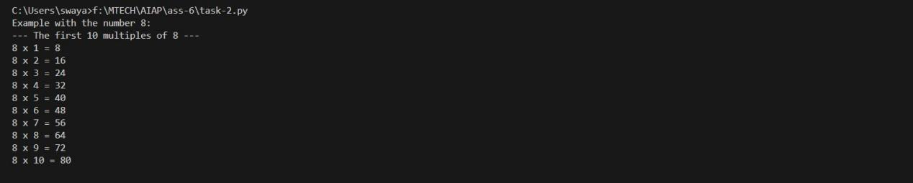
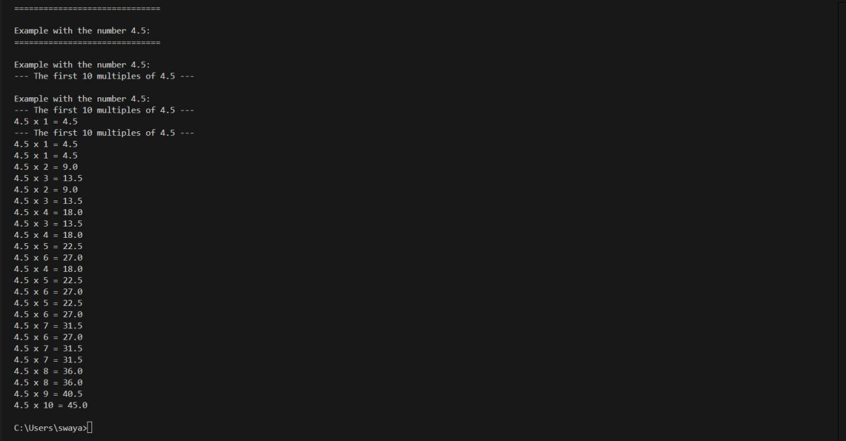

Task Description 3

• Ask AI to write nested if-elif-else conditionals to classify age groups.
• Analyze the generated code
• Ask AI to generate code using other conditional statements

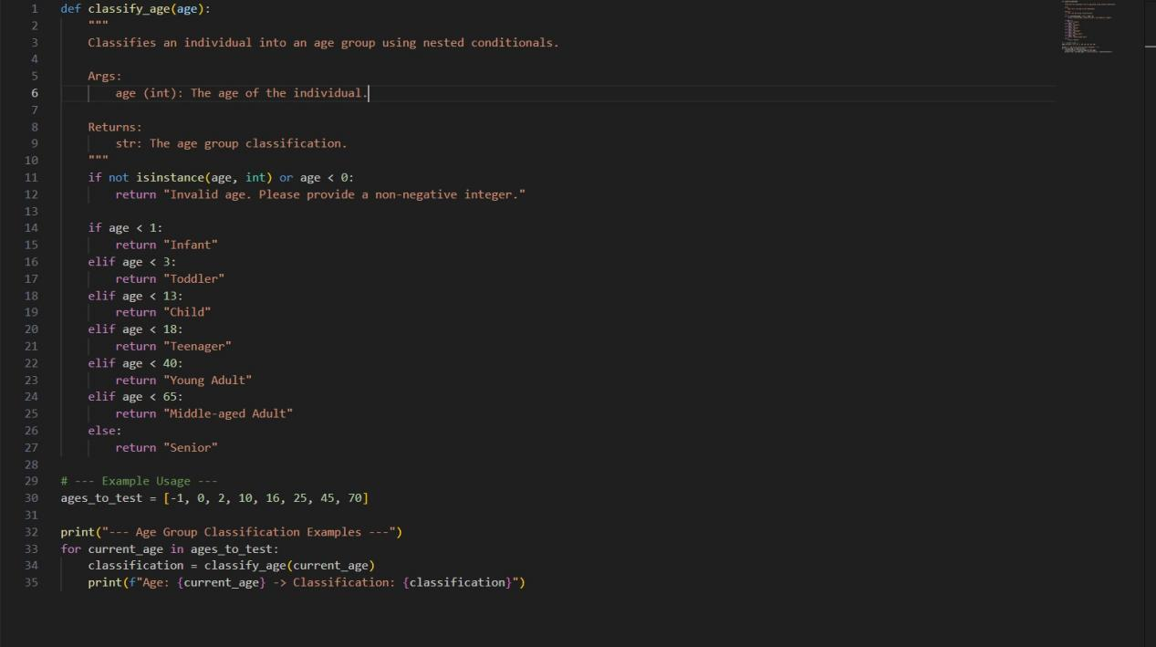

Practical Output:

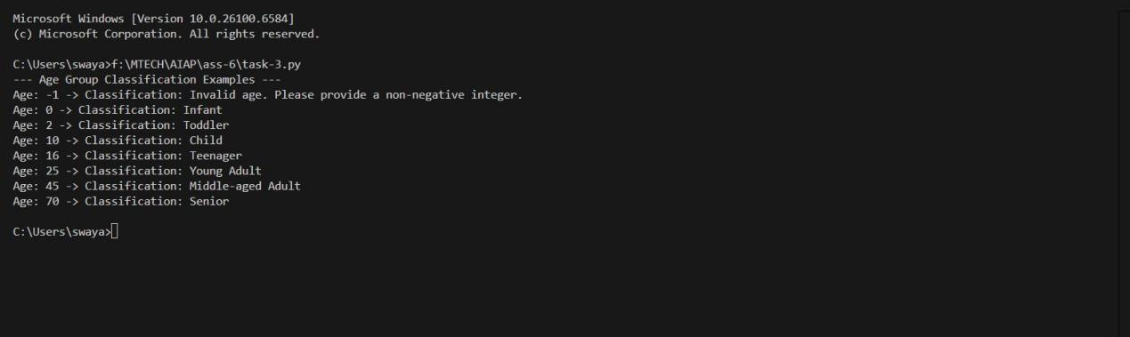

Task Description 4

• Generate a sum_to_n() function to calculate sum of first n numbers
• Analyze the generated code
• Get suggestions from AI with other controlled looping

Code
def sum_to_n(n):
"""
Calculates the sum of all integers from 1 to n.

Args:
n (int): A non-negative integer.

Returns:
int or str: The sum of integers from 1 to n, or an error message string
if the input is invalid.
"""
if not isinstance(n, int) or n < 0:
return "Error: Input must be a non-negative integer."

# Using the mathematical formula for the sum of the first n integers for efficiency.
return n * (n + 1) // 2

# --- Example Usage ---
print("--- Calculating the Sum of the First N Numbers ---")

test_values = [10, 100, 0, -5, 9.5, "hello"]
for value in test_values:
result = sum_to_n(value)
print(f"Input: {value} -> Result: {result}")

Explanation:

This script defines a single function, sum_to_n, which is designed to be a highly efficient way to calculate the sum of all integers from 1 to a given number n.

Here is a breakdown of its key components:

Function sum_to_n(n):

Input Validation: The first thing the function does is check if the input n is valid.

python
if not isinstance(n, int) or n < 0:
return "Error: Input must be a non-negative integer."
It ensures that the input is an integer and that it is not negative. This prevents the function from producing incorrect results or errors with inappropriate data types (like floats or strings).

Efficient Calculation: The core of the function is this line:

python
return n * (n + 1) // 2
Instead of using a loop to add up all the numbers one by one (which would be slow for very large values of n), it uses the famous mathematical formula for the sum of the first n positive integers. This approach is extremely fast and efficient because it calculates the result in a single operation, regardless of how large n is. The // operator is used for integer division to ensure the result is always an integer.

Example Usage Block:

The code at the end of the file demonstrates how the function works with various inputs.
It creates a list called test_values containing a mix of valid and invalid data: a standard integer (10), a larger one (100), a boundary case (0), and invalid inputs (-5, 9.5, "hello").
It then loops through this list, calls sum_to_n for each value, and prints the output, clearly showing how the function handles both correct and incorrect inputs.
Overall, this is a well-written and efficient piece of code that correctly solves the problem while also handling potential errors gracefully.

Task Description 5

• Use AI to build a Bank Account class with deposit, withdraw, and balance methods.
• Analyze the generated code
• Add comments and explain code

Code:
class BankAccount:
"""
Represents a bank account with functionalities to deposit, withdraw, and check the balance.
"""

def __init__(self, initial_balance=0.0):
"""
Initializes a BankAccount object.

Args:
initial_balance (float or int): The starting balance. Must be non-negative.

Raises:
ValueError: If the initial_balance is negative or not a number.
"""
# Validate that the initial_balance is a non-negative number (integer or float).
if not isinstance(initial_balance, (int, float)) or initial_balance < 0:
raise ValueError("Initial balance must be a non-negative number.")
# The underscore prefix on `_balance` indicates it's intended for internal use.
self._balance = float(initial_balance) # Store balance as a float for consistency.

def deposit(self, amount):
"""
Deposits a given amount into the account.

Args:
amount (float or int): The amount to deposit. Must be a positive number.

Returns:
str: A message indicating the outcome of the deposit.
"""
# The deposit amount must be a number greater than zero.
if not isinstance(amount, (int, float)) or amount <= 0:
return "Error: Deposit amount must be a positive number."
# Add the amount to the current balance.
self._balance += float(amount)
return f"Successfully deposited ${amount:.2f}."

def withdraw(self, amount):
"""
Withdraws a given amount from the account.

Args:
amount (float or int): The amount to withdraw. Must be a positive number.

Returns:
str: A message indicating the outcome of the withdrawal.
"""
# The withdrawal amount must be a number greater than zero.
if not isinstance(amount, (int, float)) or amount <= 0:
return "Error: Withdrawal amount must be a positive number."
# Check for sufficient funds before allowing the withdrawal.
if amount > self._balance:
return "Error: Insufficient funds for this withdrawal."
# Subtract the amount from the current balance.
self._balance -= float(amount)
return f"Successfully withdrew ${amount:.2f}."

def get_balance(self):
"""
Returns the current balance of the account.

Returns:
float: The current account balance.
"""
# This method provides controlled access to the account's balance.
return self._balance

# This block demonstrates how to use the BankAccount class.
# The `if __name__ == "__main__":` construct ensures this code only runs
# when the script is executed directly (not when imported as a module).
if __name__ == "__main__":
print("--- Bank Account Operations ---")

# Create a new account instance with an initial balance of $500.00.
my_account = BankAccount(500.0)
print(f"Account created. Current balance: ${my_account.get_balance():.2f}")

# --- Test Deposit ---
# Deposit a valid amount and check the new balance.
print(my_account.deposit(150.50))
print(f"Current balance after deposit: ${my_account.get_balance():.2f}\n")

# --- Test Successful Withdrawal ---
# Withdraw a valid amount and check the new balance.
print(my_account.withdraw(75))
print(f"Current balance after withdrawal: ${my_account.get_balance():.2f}\n")

# --- Test Insufficient Funds ---
# Attempt to withdraw more money than is available in the account.
print(my_account.withdraw(1000))
print(f"Final balance: ${my_account.get_balance():.2f}")

Explanation:

The BankAccount class is a blueprint for creating bank account objects. Here's what each part does:

__init__(self, initial_balance=0.0): This is the constructor method. It's called when you create a new BankAccount object.

It takes an optional initial_balance. If you don't provide one, it defaults to 0.0.
It includes a check to ensure the initial balance is a non-negative number. If not, it raises a ValueError to prevent creating an invalid account.
The balance is stored in an attribute named _balance. The underscore prefix is a common Python convention to indicate that this attribute is intended for internal use within the class and should not be modified directly from outside.
deposit(self, amount): This method handles adding money to the account.

It validates that the amount is a positive number.
If valid, it adds the amount to the _balance.
It returns a success message. If the amount is invalid, it returns an error message.
withdraw(self, amount): This method handles taking money out of the account.

It first checks if the amount is a positive number.
It then checks if there are sufficient funds in the account (amount > self._balance).
If both checks pass, it subtracts the amount from the _balance and returns a success message. Otherwise, it returns an appropriate error message.
get_balance(self): This is an "accessor" or "getter" method. Its only job is to provide read-only access to the current _balance, aligning with the principle of encapsulation.

Example Usage Block: The code under the if __name__ == "__main__": block (which I will add for best practice) demonstrates how to use the class. It creates an account, performs a deposit, a successful withdrawal, and an unsuccessful withdrawal to show how the methods work and how the balance is updated.

